**ComSonics Leakage Equipment Test Report**

This report summarizes the activities and testing done with ComSonics’ leakage detection equipment in cooperation with Unity Media / LGI in Stuttgart Germany during the week of February 2nd – 5th, 2015.

The testing was done in two primary phases: (1) Test the accuracy of the QAM Sniffer and QAM Shadow handheld devices with respect to a calibrated Rhode & Schwarz spectrum analyzer and calibrated Roberts Antennas, and (2) Field test the usability and accuracy of the Genacis QS (GQS) vehicle leakage detection system and the handheld devices.

**Phase 1: Handheld Accuracy**

The object of phase 1 was to test the accuracy of the handheld units using their built in antennas to verify how these devices compare to a calibrated reference source. This is a difficult test to perform as the surrounding environment can have a large effect on the measurement results. The ideal testing environment should be free of sources than can cause reflections such as walls, buildings, etc. For example, an open field would be a suitable testing area. However, finding such an area was not easy given the time and local area constraints. The testing site chosen for this field test was high up on a hillside that at least minimized the reflections from the sides and back of the test area. The test leak was generated by a QAM Marker generator powered by an inverter located inside the technician’s service vehicle. Photos of the test area and set up are shown below:

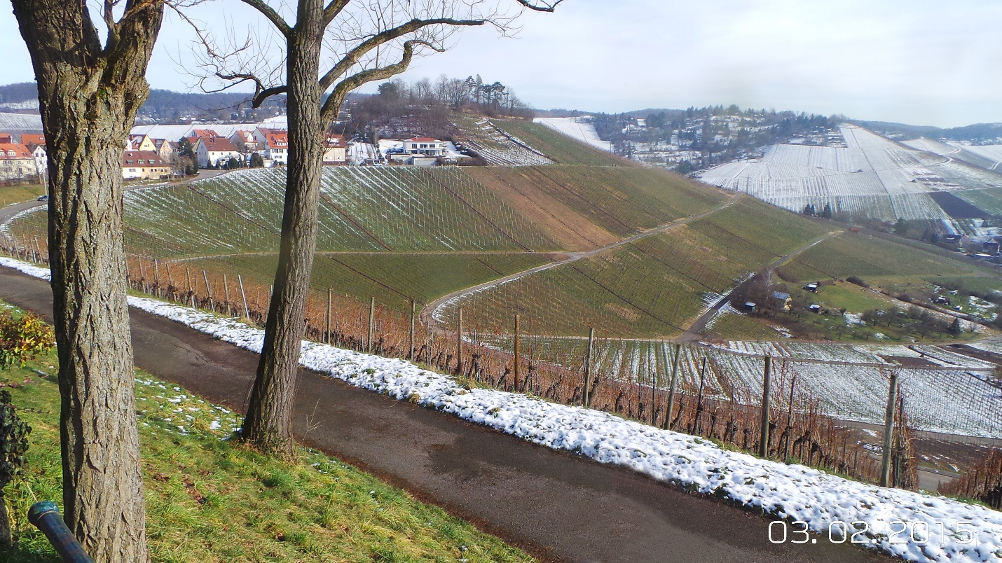

Test Location Site, Back View

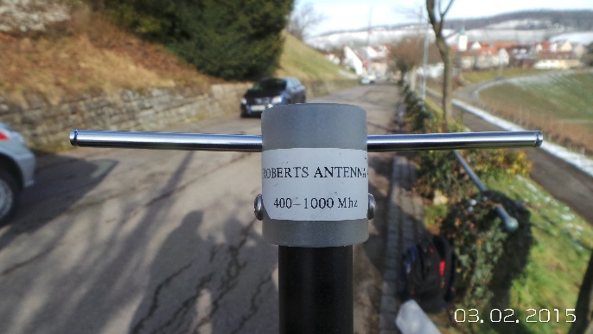

Roberts Calibrated Antenna 400 to 1000 MHz

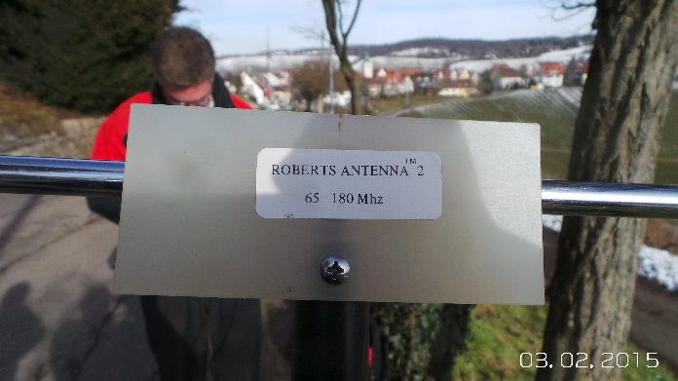

Roberts Calibrated Antenna 65 to 180 MHz

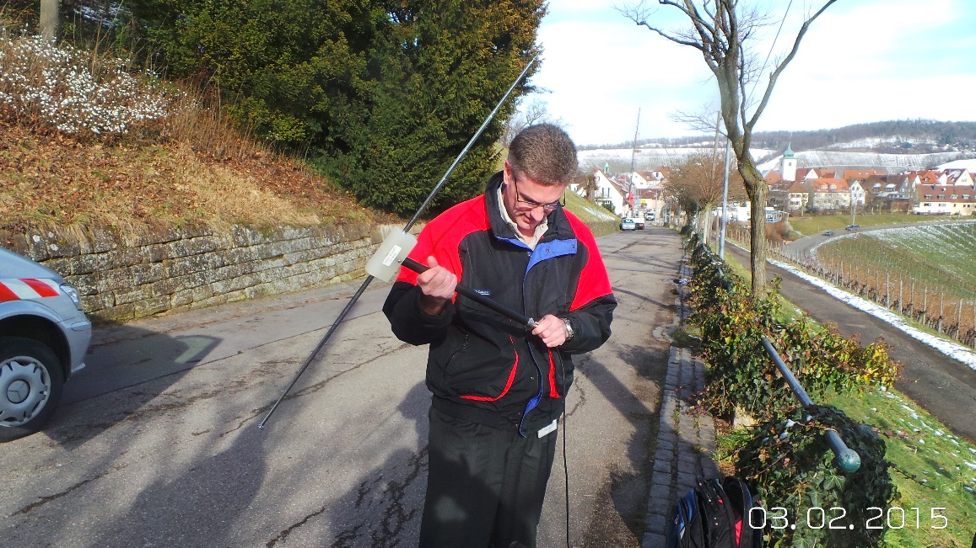

Connecting the Roberts Antenna tuned to 138 MHz

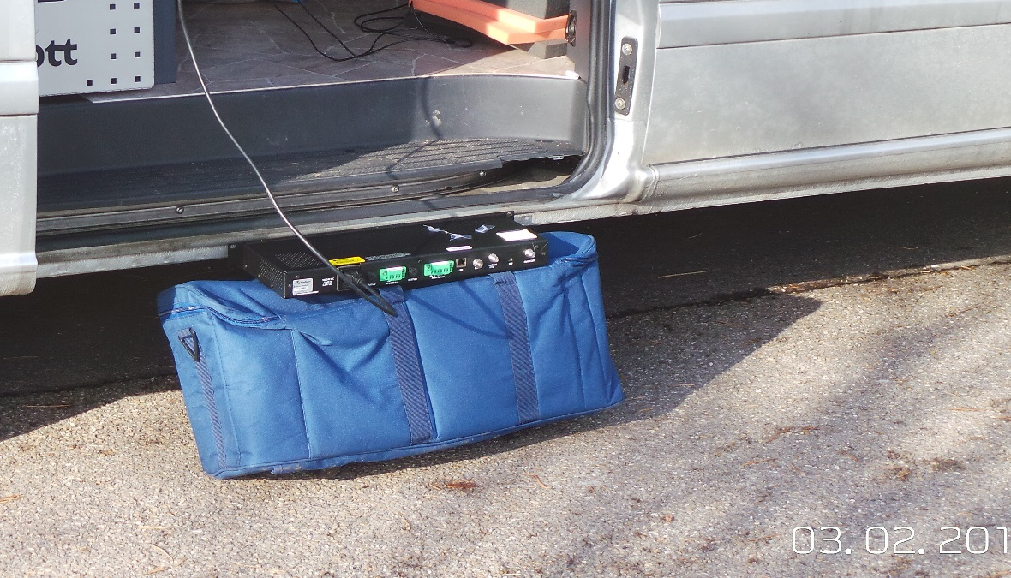

QAM Marker box used to generate cable leakage signal

The reference field strength measurement was performed using a Rhode & Schwarz Spectrum Analyzer and the Roberts Antenna’s at a distance of 3 meters (10 feet) from the QAM Marker leakage source to the measurement point.

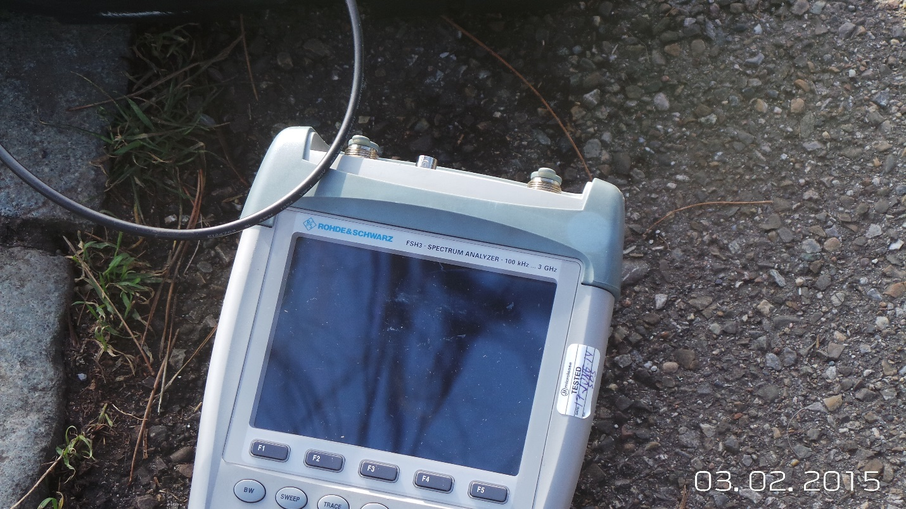

Rhode & Schwarz Analyzer

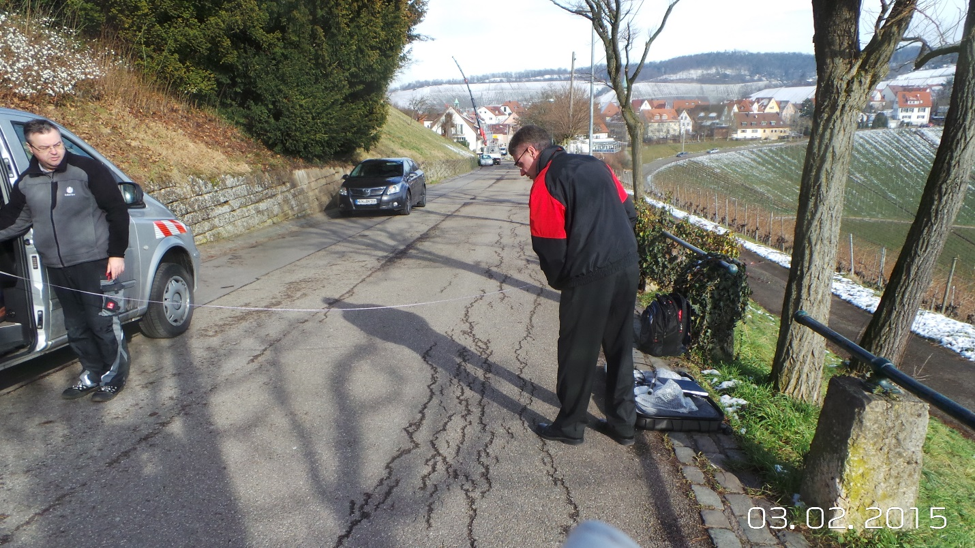

Measuring 3 meters (10’) from Marker to Test Spot

Measurements were then performed at the measured 3 meter distance and constant height using the spectrum analyzer, QAM Sniffer, and QAM Shadow. The results were recorded for each measurement.

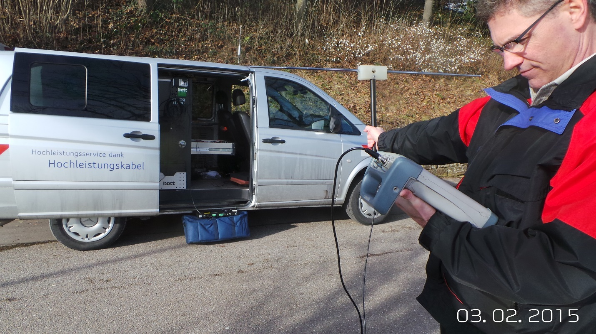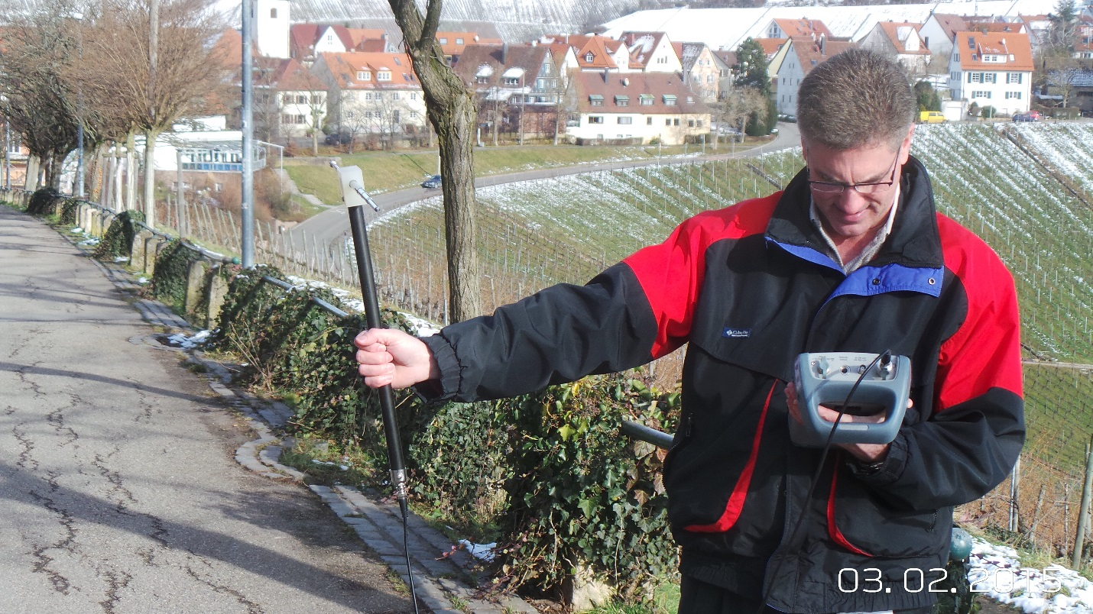

Measurements performed with Spectrum

Measurements performed with Spectrum

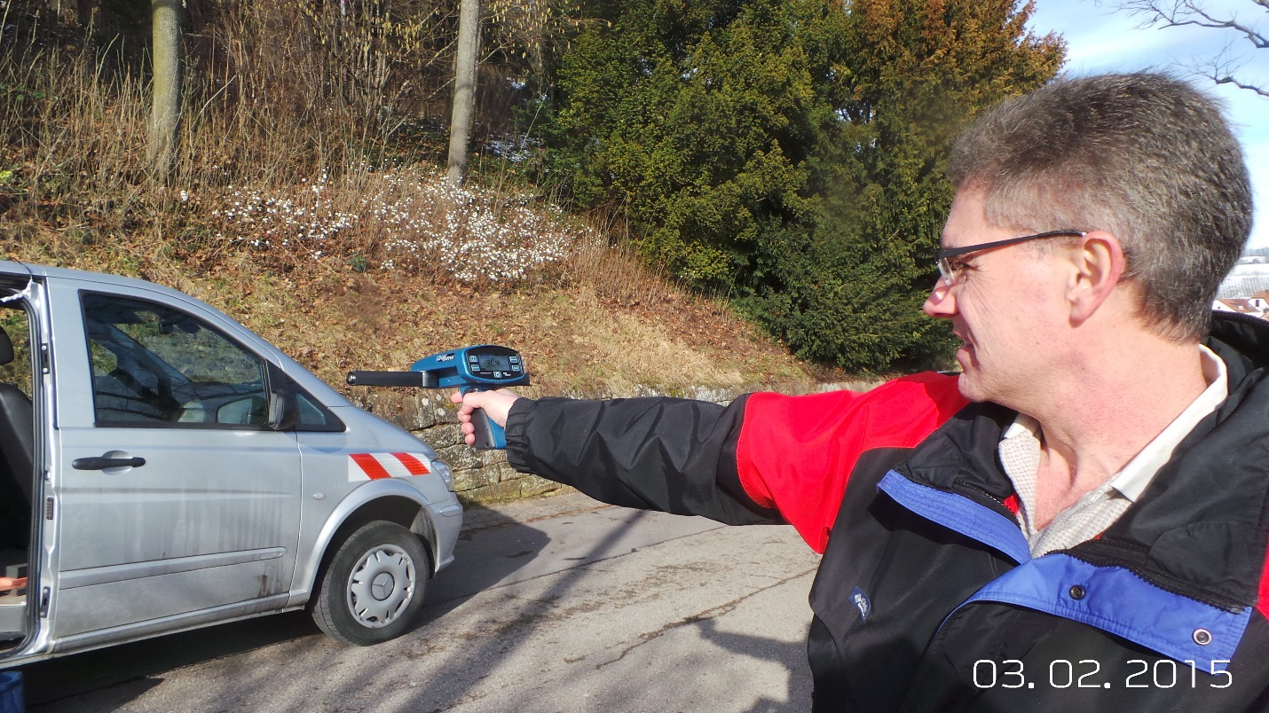

Measurements performed with QAM Sniffer

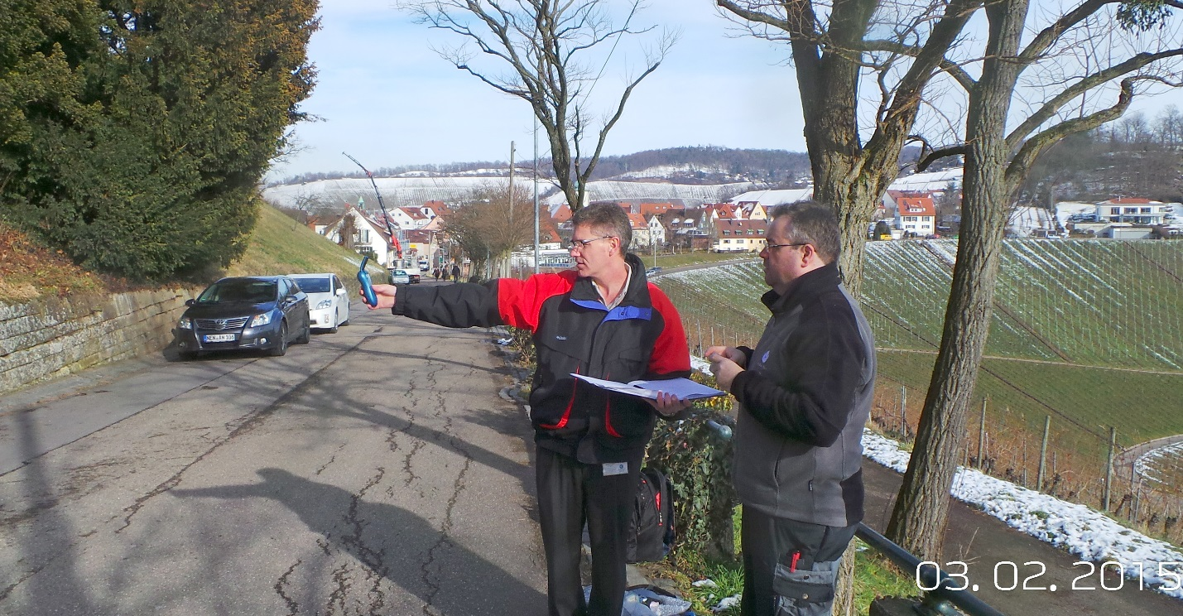

Measurements performed with QAM Shadow

All test variables were controlled as much as possible given our test constraints. The results of the test measurements for each of the devices is captured in the following table:

|  |  |  |  |  |  |  |
| --- | --- | --- | --- | --- | --- | --- |
|  |  |  |  |  |  |  |
|  | **Accuracy Test Results for Unity Media / LGI** | | | |  |  |
|  | Stuttgart, Germany | |  |  |  |  |
|  | 3-Feb-15 |  |  |  |  |  |
|  |  |  |  | **µV/m** | **dBµV/m** |  |
|  | **614 MHz** |  |  |  |  |  |
|  |  | Rohde & Schwarz | -115 dBm | 295 µV/m | 49.4 dBµV/m |  |
|  |  | QAM Sniffer |  | 350 µV/m | 50.9 dBµV/m |  |
|  |  | QAM Shadow #1 |  | 325 µV/m | 50.2 dBµV/m |  |
|  |  | QAM Shadow #2 |  | 350 µV/m | 50.9 dBµV/m |  |
|  |  | Antenna Factor = | 24.4 dB |  |  |  |
|  |  |  |  |  |  |  |
|  | **138.5 MHz** | |  |  |  |  |
|  |  | Rohde & Schwarz | -95.3 dBm | 630 µV/m | 56.0 dBµV/m |  |
|  |  | QAM Sniffer |  | 600 µV/m | 55.6 dBµV/m |  |
|  |  | QAM Shadow #1 |  | 800 µV/m | 58.0 dBµV/m |  |
|  |  | QAM Shadow #2 |  | 794 µV/m | 58.0 dBµV/m |  |
|  |  | Antenna Factor = | 11.3 dB |  |  |  |
|  |  |  |  |  |  |  |

**Analysis of Results**

The measurement results at 614 MHz show that all equipment measured to within 1.5 dB with respect to each other, representing a very high degree of accuracy and consistency at this frequency range. At 138.5 MHz, the QAM Sniffer had a 0.4 dB delta compared to the R&S and the QAM Shadows demonstrated a maximum variance of 2 dB from the R&S reference measurement. This variance is within the ±2 dB specification that is difficult to achieve given the influences of the test environment and methods. ComSonics has performed independent accuracy measurements in a more controlled test environment to show that the measurements at both 614 MHz and 138 MHz are well within specifications. It is also important to note that while the QAM Shadow performance met its stated specifications, it is primarily designed to be a near-field measurement device used to locate and find leakage at a close range and is not designed to be a precision measurement instrument, particularly at lower frequencies / long wavelengths.

**Phase 2: Field Study Results**

The second testing phase was to find and locate leakage in the surrounding cable plant using the ComSonics Genacis QS (GQS) system at both the VHF (138.5 MHz) and the UHF (614 MHz) frequencies. The objective was to identify several specific leaks from the map, travel to the location site, use the QAM Sniffer / Shadow to locate and verify the leakage, and to the extent possible determine the cause of the leakage. This test methodology validates several aspects of the ComSonics solution including:

1. The GQS system accurately identifies leakage in the cable plant both in location and in relative amplitude.
2. The ability of the QAM Sniffer to provide directionality information that aids the technician to track down and find leakage.
3. The usability of the equipment including aspects such as ease-of-use, portability, handling, battery life, etc.

Two vehicles were equipped with a GQS system and then preformed short drive outs in order to start capturing leakage data. The Unity Media field service team was given access to the Genacis Web application that shows the location and level of leaks detected. Two leaks were chosen to perform the field tests on. The following photos show the GQS system in vehicles and the Genacis map which identifies the two leaks that were used for the testing.

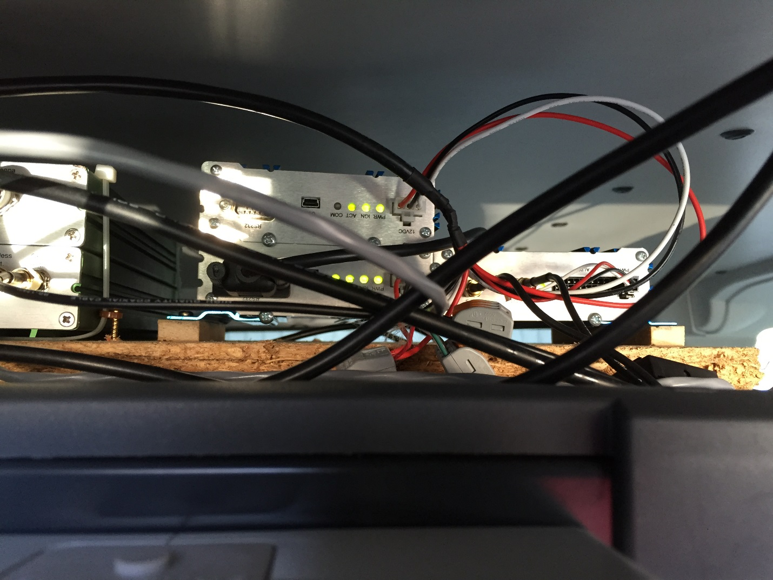

Dual Frequency GQS system Installation in tech’s vehicle

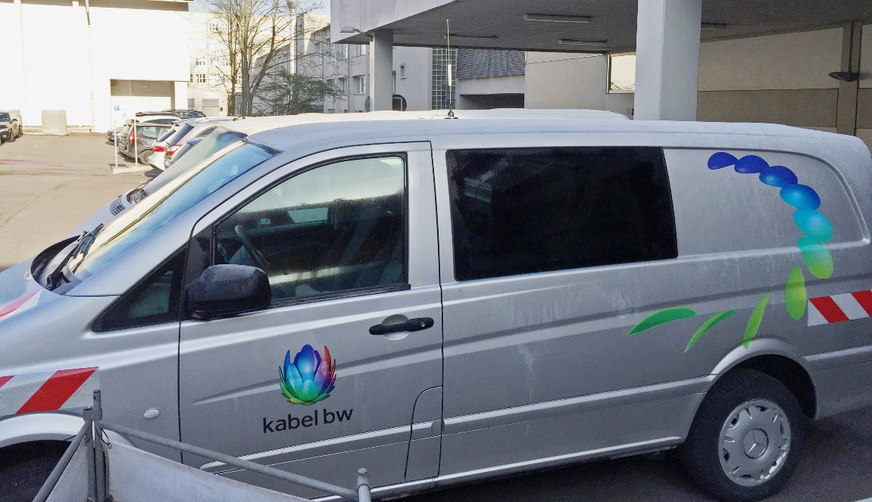

Unity Media Vehicle with GQS installation

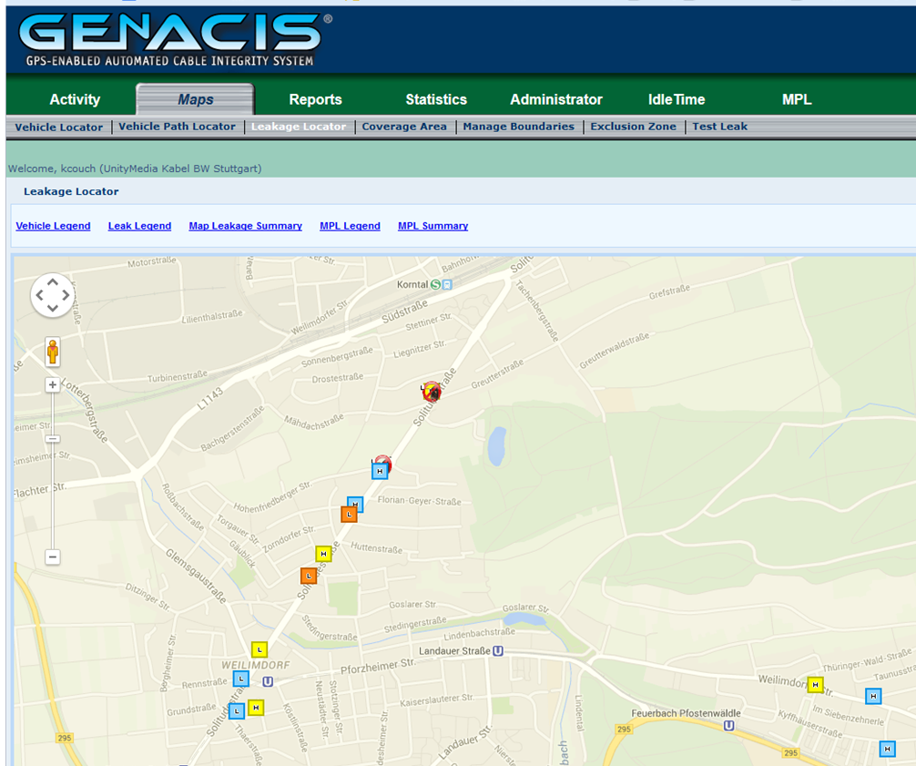

Leak #2: 50 dBuV/m

Solitudestrase 327

Leak #1: 52 dBuV/m

Corner of Solitudestrase

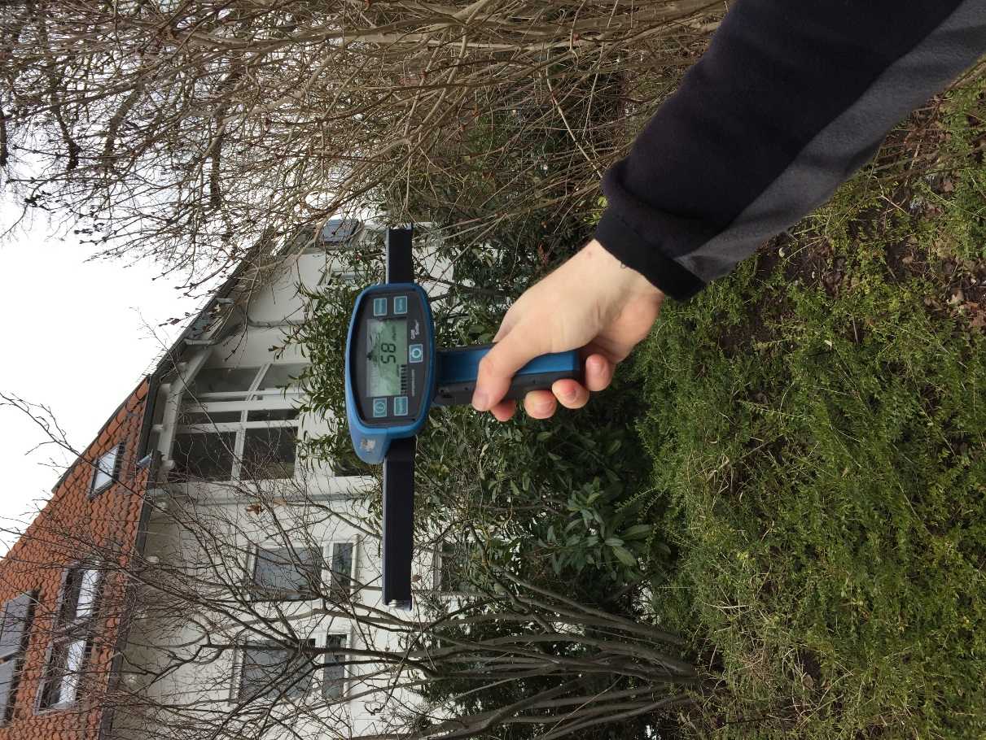

**Leak #1 Results**

After arriving at the designated location indicated on the map for Leak #1, two QAM Sniffers were used to locate the leak using the directionality of the device. The conclusion was that the leak was coming from an apartment building on the 2nd or 3rd floor. The indicated level was between 53 dBµV/m and 58 dBµV/m at approximately 10 meters from the house.

An attempt was then made to find the leak inside the apartment building by entering the building and tracking down the individual apartment. The first attempt to locate the leak was in a 2nd floor apartment that had been given access to us by the owner. It was quickly determined that the leakage was not in the apartment by looking for leakage in close proximately to the existing TV and cable outlets. We moved to the 3rd floor where higher levels of leakage were found and localized to the leak to apartment #5, however the owner was not home. In order to validate that the leakage was coming from this apartment, the cable feed in the basement was temporarily removed and the leakage rechecked. Removing the cable feed to apartment #5 verified that the leak was coming from this apartment. Unity Media left a note to the apartment owner to contact Unity Media for a service repair.

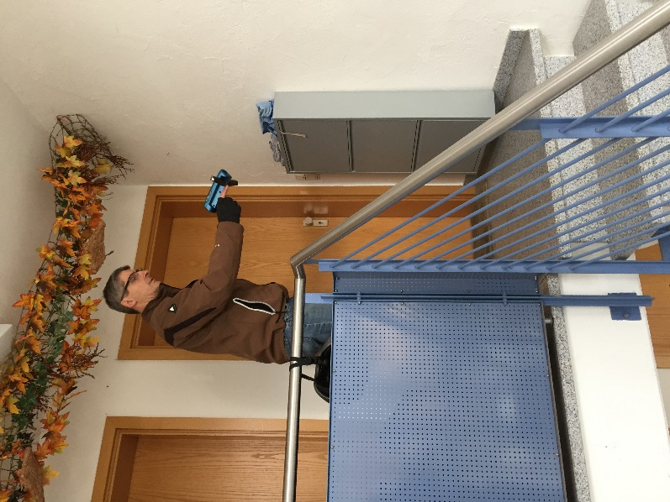

Finding Leak inside building

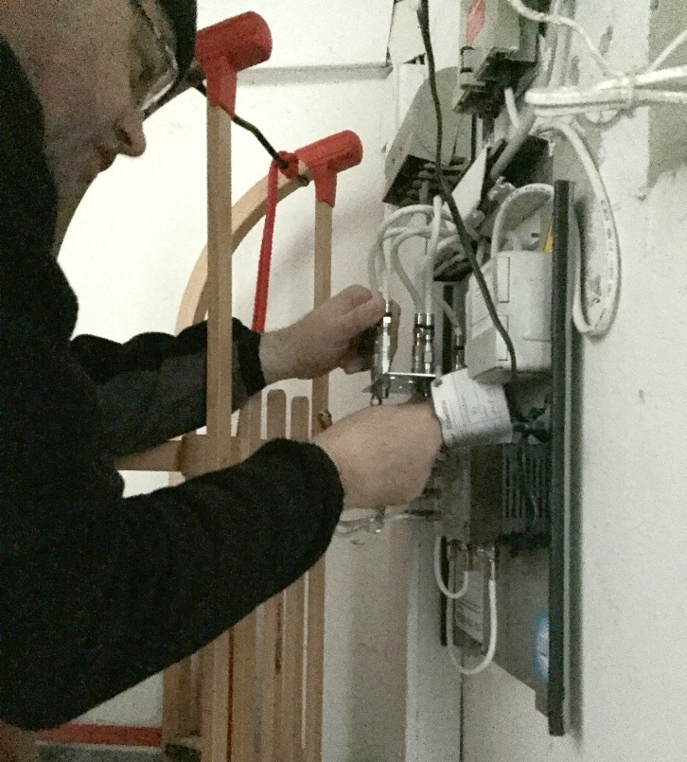

Isolating Leak using feeder in basement

Locating Leak #1 in Apartment building

**Leak #2**

We then moved to Leak #2 as indicated by the location on the Genacis map. After the general location was reached, the team started searching for the leak. A short time later, the leak was determined to be coming from the 2nd story of an apartment building. The owner of the building had come out to find out what we were doing. Following a brief explanation, the owner allowed the technician to gain access to the incoming cable feed located in the garage of his building. The cable feed was disconnected and the leakage disappeared, thus validating its location. The measured value of the leakage on the QAM Sniffer was 44 dBµV/m at an approximate distance of 30 feet.

**Summary**

In both cases, Leak #1 and Leak #2, the field study verified that the GQS system accurately identified both the location and level of the leakage. Also in both cases, the Unity Media technicians were able to quickly locate, identify, and verify the source of the leakage.

**Additional Feature Information**

As a separate exercise, ComSonics’ Mobile Problem Locator (MPL) application was used to identify leakage in combination with a QAM Sniffer and plot it on the Genacis map to show how technicians are able to easily add leakage in a manual fashion. The following is a snapshot of the Genacis map and MPL application to verify the application can be used to capture leakage in a drive out area.

Screenshot of MPL Application

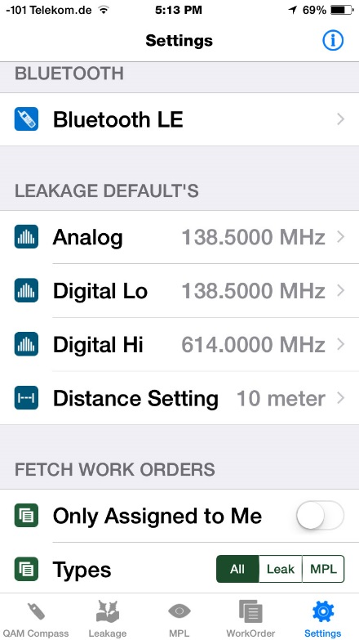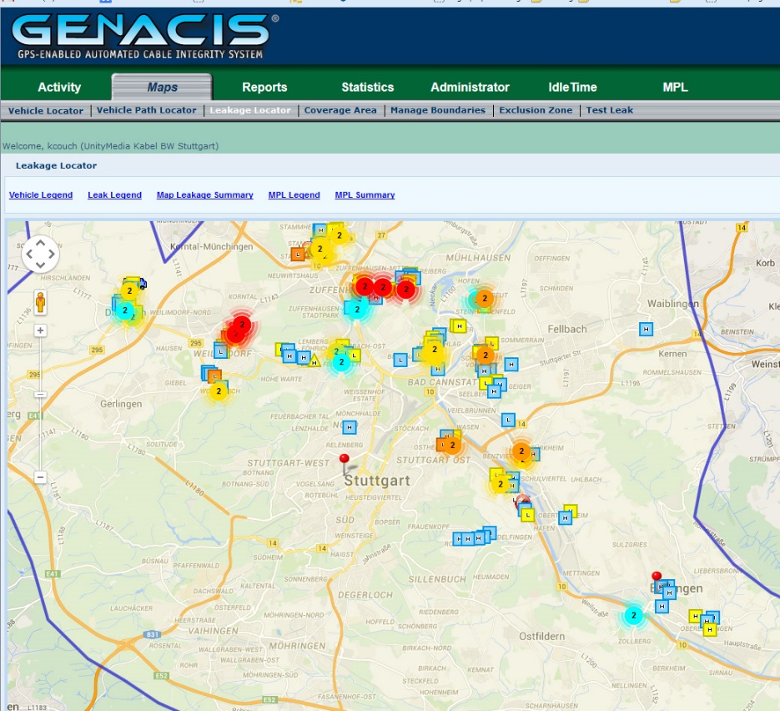

Leakage recorded using MPL application

The MPL application is a valuable tool that allows technicians to manually record leakage when they are not able to fix the leakage during their scheduled workday. It can be used in combination with the GQS solution to provide a more comprehensive method to capture leakage information or in a standalone application.